Time Series Forecasting:
Bitcoin Price
Ian Culp
Holberton School - Tulsa
Machine Learning
May 11, 2021
Time Series Forecasting: Bitcoin Price
Time series forecasting is essentially predicting the future value of some continuous variable based on historical data. In statistics this is referred to as extrapolation, making inferences for new data beyond the current dataset. The key in time series is the sequencing of events, or successive nature of the datapoints, ordered over some period of time.
There are a variety of methods to implement a time series forecasting model. They all essentially examine historical data to identify trends and patterns in order to predict future values. Various patterns can occur within time series data. Seasonal patterns can occur along with the weather or time of year, as well as cooccurring with other regular events. Cyclical patterns are also regularly found, and trends can occur during various ranges of time.
Preprocessing
When running machine learning models, computations can not be performed on missing values. Similarly, 0 values during computations will zero out the results, making training ineffective. These kinds of missing values either need to be removed or filled in with imputed values, such as a central measure such as the mean, which shouldn’t bias the data in either direction. You can gauge whether rows or attributes need to be removed by comparing how many missing values there are to the total.
Visual inspection is the best place to start. By opening the csv and scrolling through the records I could see that most of the missing values were in the early years. This is when the price of bitcoin was very low, and the exchange service was just starting and services were inconsistent. As time went on and the exchange improved the performance of their services the price data was more regular and continuous.
To simplify this process, I removed all the missing rows that contained a missing value at all and compared the number of rows in my new dataframe to the original by subtracting the difference and dividing by the original length. This resulted in roughly 5% of the rows being removed, which was sufficient for this project and not necessary to impute values.
After processing the data to remove any row with an NA, I needed to reset the index to a sequential index, which is easy enough with pandas. I also discovered that reading and writing to csv with pandas was stacking columns for the index each time. In order to prevent this I needed to set the read/write parameters to index=False.
After removing the missing values, I decided to run principal component analysis, PCA, to dertmine which features (columns) to keep. Keeping every column would increase the time to make computations over the entire dataset, making training longer and more expensive. PCA can help us to identify the most important features to keep. With scikit-learn we can also transform our dataset to normalized values at the same time.
Initially I had preprocessed the data and manually normalized the values for every column except for the timestamps. After I decide to do PCA, this has a function to convert the dataframe into a numpy array, perform the dimensionality reduction (keeping the n principal components that have the highest impact), and normalize the data all in one step. I decided away from this step as it would normalize the timestamps too, so I decided it was better to do manually.
When running the PCA I discovered that it thought the timestamps column was explaining all the variance. Since this would steadily increment upwards and was also not normalized, I decided to remove it altogether. Afterwards it decided that open, high, and low explained 74.9%, 21.4%, and 3.6% respectively, with 0s for the remaining columns, so these are the columns I decided to keep.
I realized I ran the PCA after normalizing, so I tried it again without normalizing and it found that the open column accounted for 99.7% and the high for 0.3%. So I ran a fit_transform to keep these 2 components and return a numpy array with both columns normalized. I’m not sure why the PCA gave different results after denormalizing or not.

Data Pipeline
Initially, after preprocessing the data and writing it as a csv, my next function read that data back into a dataframe. My first stab at this I didn’t use the tensorflow data module for my pipeline. I instead just converted the weighted average price column to a numpy array, reshaped it and fed it directly into my model.
My next stab includes PCA to reduce the dimensions keeping the ideal features for training. It also included the tensorflow.data module to feed into the model. This can be used for the entirety of the extract, transform, and load (ETL) process, but I am more familiar with pandas.
I realized in the second iteration that for my plots, I’d want to fix my data preprocessing function to keep the timestamp, so I could load it in and pop it into a separate array after converting it to the datetime format. This would allow me to create plots with the dates on the x-axis.
When loading the dataframe back into pandas, in my forecasting function, ignoring the original index, I performed the dimensionality reduction using PCA, and storing the important features in a dataframe which includes only the 2 most important features, normalized during the call to fit_transform. One of the tricky pieces was remembering to convert the transformed numpy array back into a dataframe for my windowing function; keeping the column names before dimension reduction was necessary.
To build a model that could take in an input range including multiple timesteps, and predict an output for future timesteps, a windowing function was necessary to split the inputs and reshape them into a format the model could ingest in a range of steps. The window generator will split the inputs into multiple batches, over a range of timesteps, to train over the reduced number of features. This creates input shapes of (batches, timesteps, features).
The last piece of the data pipeline was to convert the dataframe into a tf.data.DataSet for the tensorflow model to ingest. This function was created and added as an attribute to the window generator. Ironically, this takes my dataframe and converts it back into a numpy array before converting it into a keras timeseries. Lots of transformations going on back and forth during the building of this pipeline 😊
Model Architecture
We are relying on neural networks to learn the patterns and trends in order to predict future values. RNN’s, or recurrent neural networks, are especially good at training over time series data as there are multiple paths the inputs and outputs of each layer travel in order to “remember” learned patterns from earlier layers or epochs during training. In my model, we’ll rely on what’s called a LSTM, or long-short term memory layer. These are most effective for use in training over time series data, but are slightly more computationally expensive than a GRU, which is a simpler form of RNN.
The first try I used a sequential model using a lstm layer followed by a dense layer, mean squared error for the cost function., and Adam optimization for the network. I was not providing a window to the model, and therefore my outputs were mirroring my inputs (essentially my input and ouput timesteps were the same). At first I thought I had built a perfect model! You can see in the graphic that the predicted values were identical to my test dataset, which I had separated from the last weeks worth of data, so the model had not seen this portion during training.
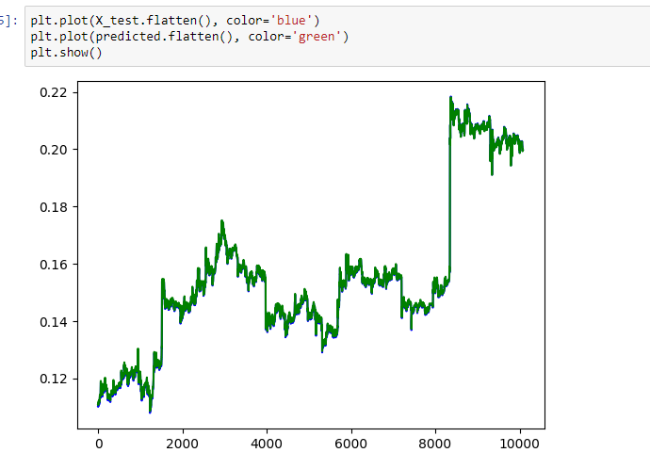
I trained this model over several iterations; I discovered that increasing the number of units in the LSTM layer increased the training time, but reduced the gap in the predicted values from the test data. I also tried variations of LSTM, GRU, and simple RNN networks. I initially included a dropout layer to reduce overfitting, but this didn’t seem to have much affect. I changed this to a dense layer with 1 unit, and this improved the model.
After I used the window generatiing function, the predicted outputs were one timestep beyond of each 24 hour window worth of input data used during predictions. This made for better viewing of the predicted outputs and prevented the data from predicting itself.
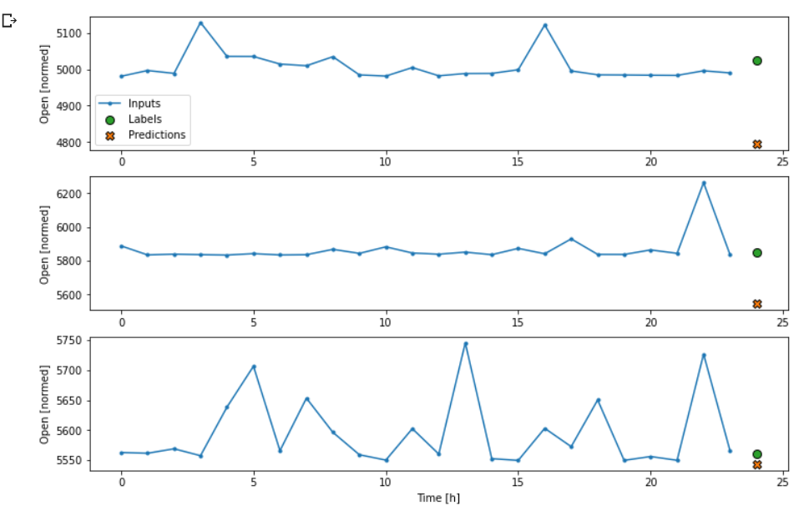
After training my model this way I realized that fit_transform wasn’t normalizing the data. I could see this in the y-axis being accurate, but also because my mean absolute error was a large number.
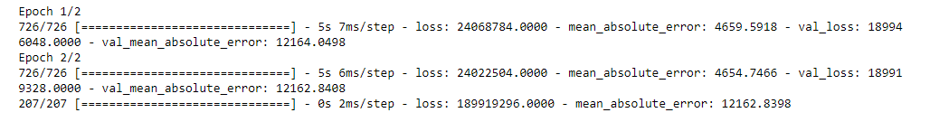
I then retrained after normalizing to see how this affected my performance. The outputs were similar, but my axis was the narrow range around 0. At this point I also, to reduce the training time, selected from either 60th row (df = df[::60]) so that each datapoint represented the next hour’s price point. This drastically reduced training time, but resulted in weird outputs. I ultimately settled on 10 minute intervals.
Now that I was normalizing my data, I needed to denormalize it in the plotting functions to view the appropriate scale on the y-axis. This would change the output back to normal, instead of something like this:
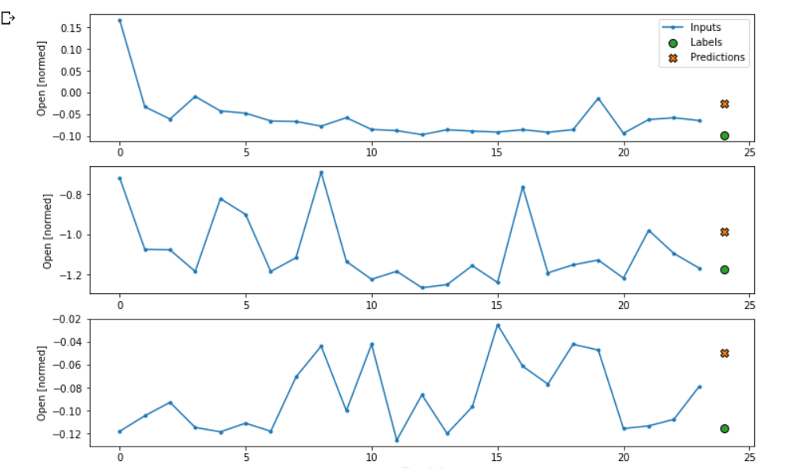
To denormalizing the predictions I needed to modify the code to store the mean and std during normalization, then multiply by the standard deviation and add the mean when plotting to see the denormalized results. I stumbled on this part and wasn’t able to denormalize the results in a meaningful way. So I ended up commenting out the normalization step and letting the model train without it.
Results
After training on 10 minute intervals with the data not normalized, I got decent output:
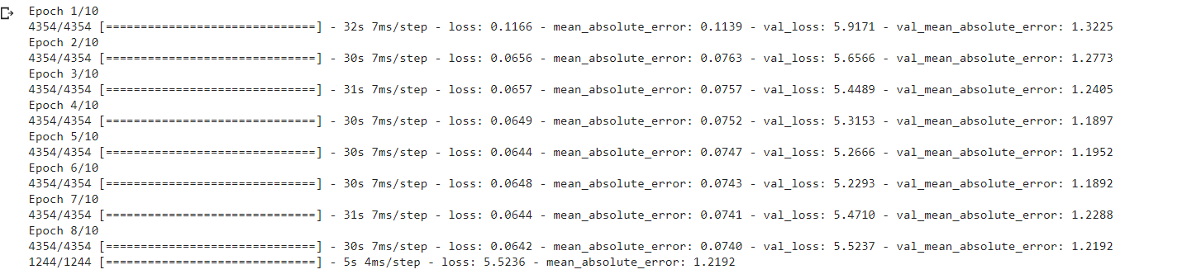
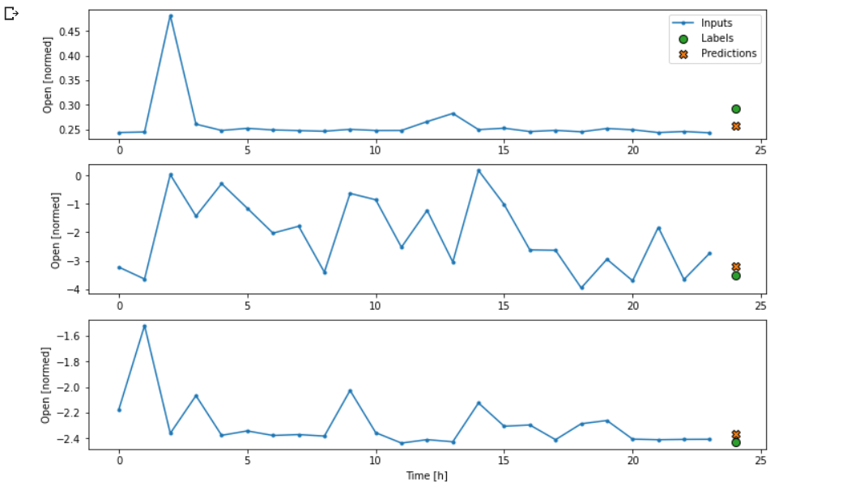
You can see the results are normalized; after commenting out the normalization code and retraining I got worse results, but with the full y-axis in my outputs. At this point it was too late to continue troubleshooting.
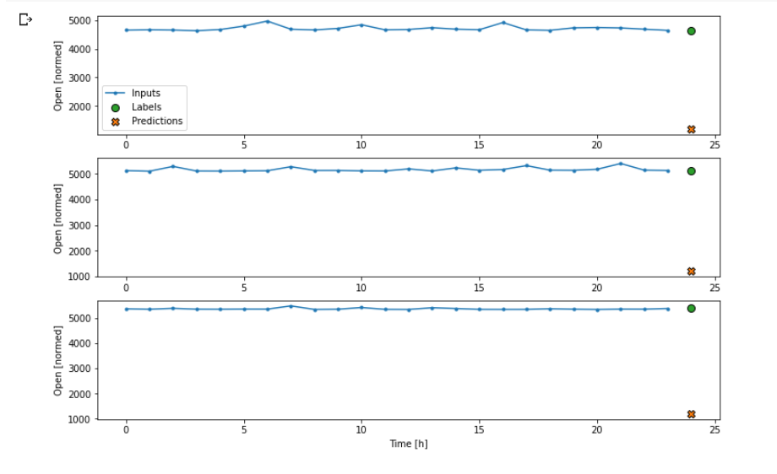

Conclusion
During this project there were many stumbling blocks and frustration points that I didn’t document. After breaking my anaconda environment, I spent several days trying to troubleshoot why I couldn’t get my GPU to be recognized within my jupyter notebooks. I wound up relying on google colab once again.
This was a very interesting project to work on and I’d like to continue working on it. I’m especially interested in building a model similar but with multiple outputs, ie outputs over multiple timesteps instead of a single output for one timestep. I would essentially like to build a model that feeds the outputs from the previous steps into the inputs for the next steps. This would allow me to plot the predictions along multiple timesteps and see how well it guesses over time. This would also give be a basis for autoregression, which would allow me to feed in price data in real time, as well as my predictions over time which get fed back in, and the model can continuously predict the price in real time.

